110 Q3 WED 16/7 Sec_StudentID ___________ Name in CAPITAL _______________________
You can use pencil / pen / both. Pencil users cannot report problems/mistakes in checking this quiz paper when it will be returned back to you after checking. Forgetting to fill above blanks means, you are absent. You can use the other side of the pages as well for any of your answers if you need more space.
- Do not overwrite, instead cross out/strikethrough like this and write again.
- Understanding the question is part of the exam. Manage space well/use column, no extra page will be given

Q1) Write javacode of a program that asks the user the value of n, and then prints out first n values of the following sequence: 1 -1 1 -1 1 -1 . . . . .

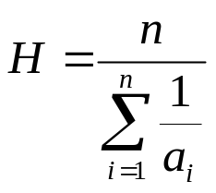

Q2) Write javacode of a program that asks the user the value of n, and then takes value of n numbers (a₁, a₂, … a_{n} ) from the user and prints the Harmonic Mean (H). Hint: first calculate the sum, then divide.

